Preprocessing: All preprocessing was performed as described in the methods section of Semedo et al “Cortical Areas Interact through a Communication Subspace” Neuron 2019, including mean-matching, calculation of residuals, partitioning by stimulus type, and repetition of datasets x 25, with results averaged across reptitions. No normalization of neural responses performed.

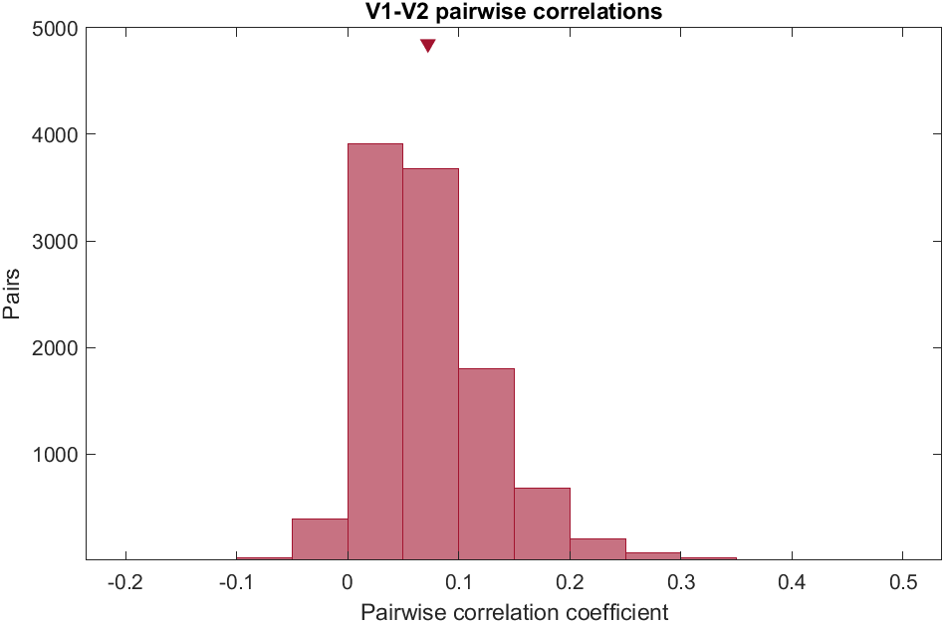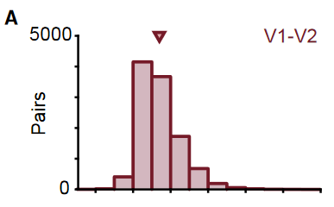

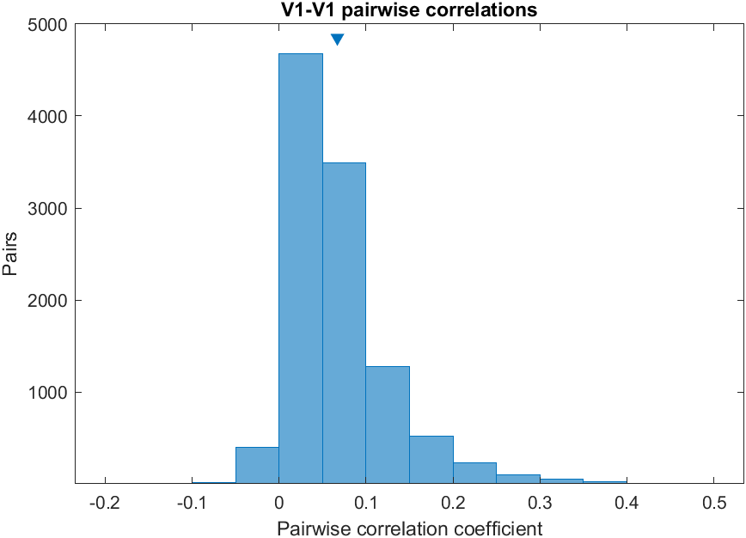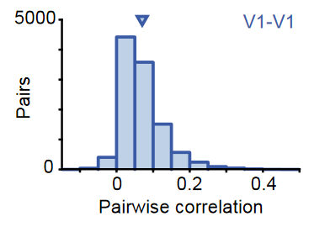

**Figure 2A replication (left) vs published (right)**. Top row features histograms of pairwise correlation coefficients between single units in source V1 and V2 (under one mean-matching procedure, as in the published work). Bottom row features pairwise correlation coefficients between source V1 and target V1 (again, after one mean-matching procedure). Triangles denote mean across all pairs. Left histograms each feature 10,772 pairs compared to 10,944 in the published work—the difference is most likely due to how many bins were used in the mean-matching procedure. Overall, results are quite similar.

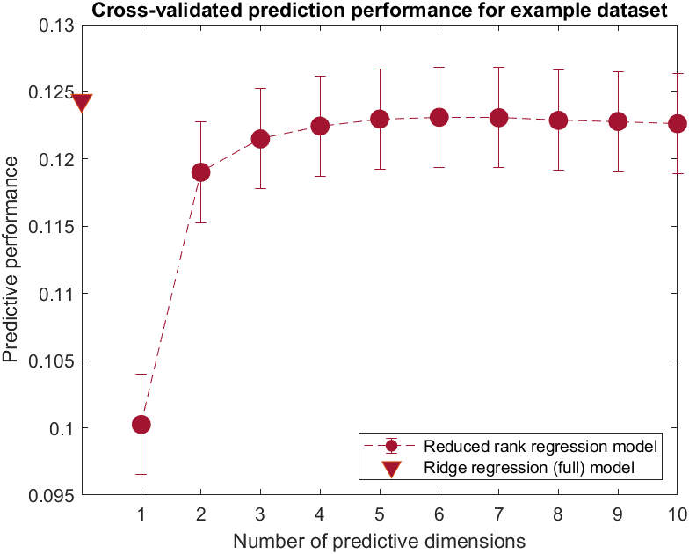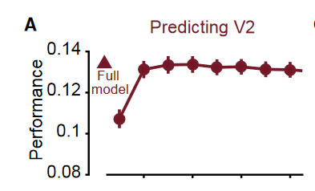

**Figure 4A, replication (left) vs published (right)** Exemplar dataset showing that fewer predictive dimensions are required to achieve peak explanatory performance when predicting V2 activity based on source V1. This small subset of V1 dimensions predictive of V2 activity suggests a selective subspace that communicates with V2.

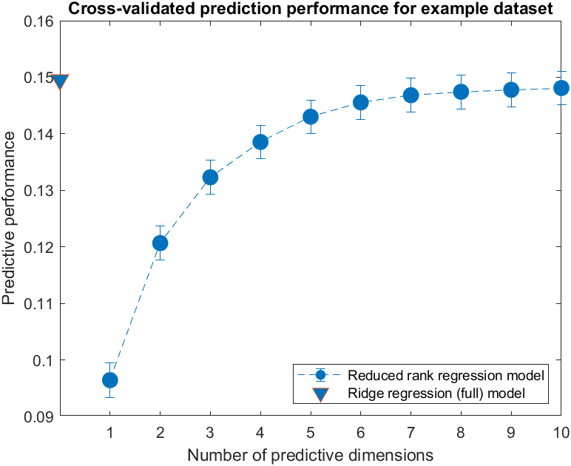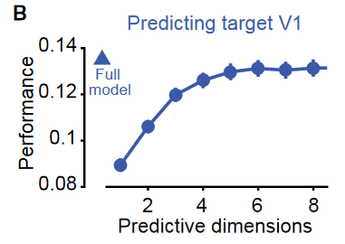

**Figure 4B, replication (left) vs published (right)** Same exemplar dataset showing source V1 – target V1 interaction. In contrast to the source V1 – V2 case, here a maximal number of predictive dimensions is used. This makes sense, as it suggests that there is not some part of a functional area such as V1 that is somehow private from itself.

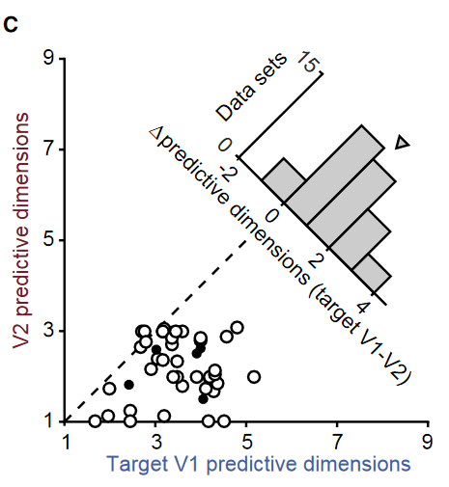

**Figure 4C, replication (left) vs published (right)** Instead of exemplar datasets, we look here at all datasets together and note that V1 consistently requires more predictive dimensions than V2. This is the first place where things aren’t exactly the same as the published work, as we can note that the cluster of points is shifted positively along both axes, but especially the V1 axis, suggesting that during the replication runs, more predictive dimensions were needed in both areas, but especially in V1 (Figure 5B is related to this). For prediction of V2, across all datasets and all numbers of predictive dimensions, mean performance of the RRR model was 0.1453 ± 0.0073 compared to 0.1512 ± 0.0074 for the full ridge model. For prediction of target V1, mean performance across datasets and numbers of predictive dimensions by the RRR model was 0.1174 ± 0.0079 compared to 0.1254 ± 0.0082 for the full Ridge model.

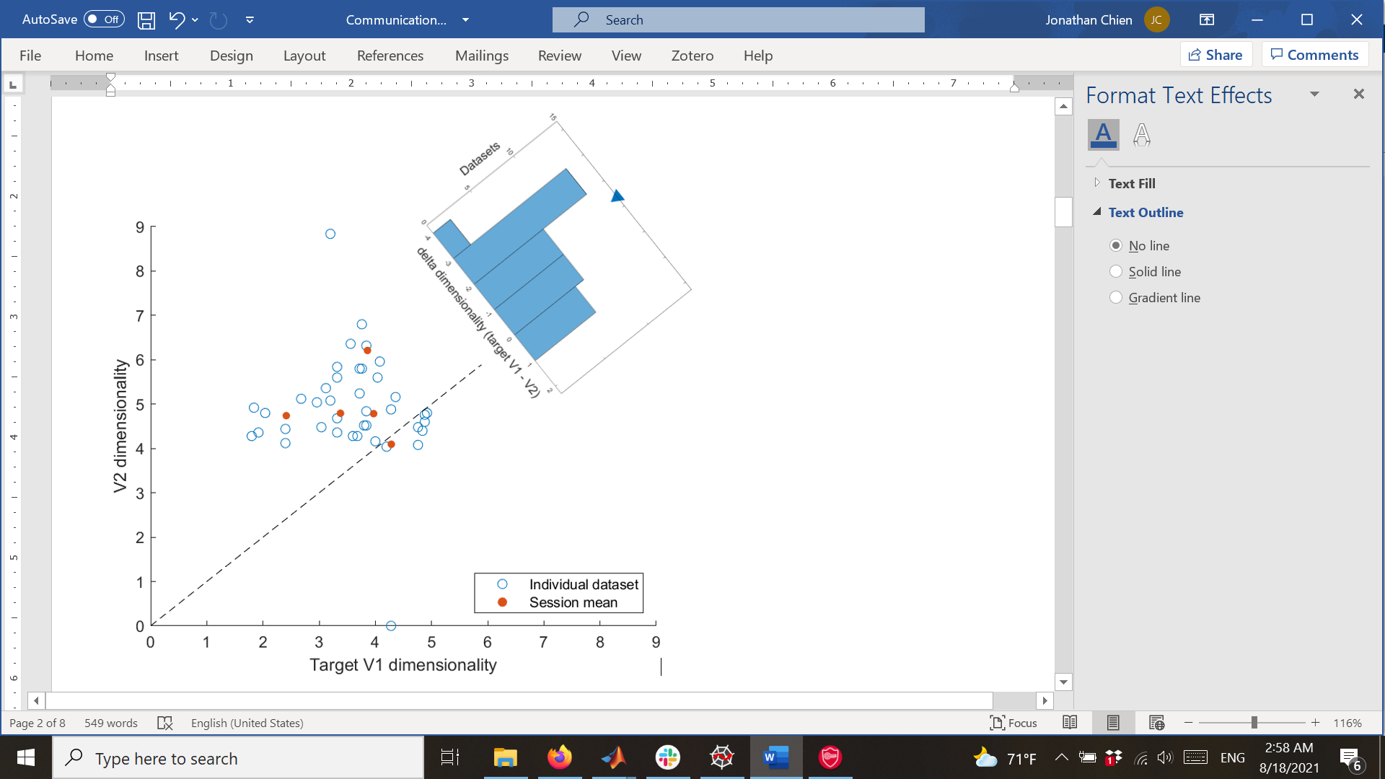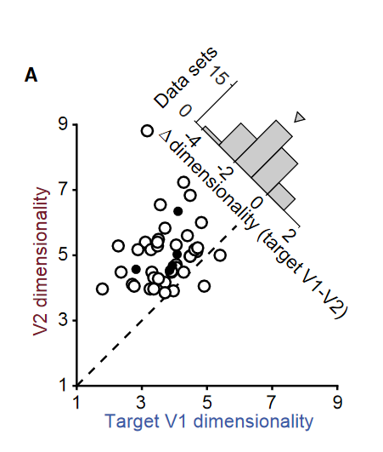

**Figure 5A replication (left) vs published (right)** Activity in V2 is actually higher-dimensional/more complex than in source V1, suggesting that it is not lower dimensionality in V2 that is responsible for the smaller number of predictive dimensions needed for peak prediction of V2 activity based on source V1 activity.

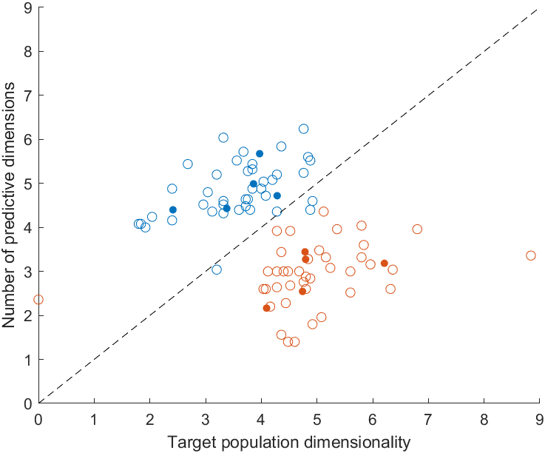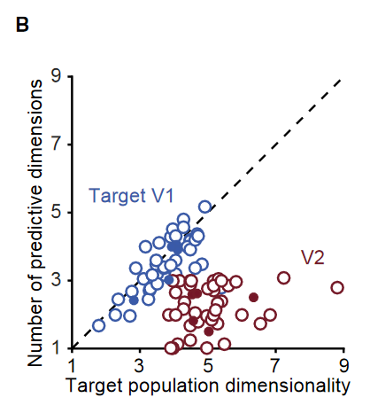

**Figure 5B replication (left) vs published (right)** On the left is the figure that probably least resembles its published counterpart. The orange/red part matches up, suggesting again that it is not low-dimensional activity in V2 that accounts for the relatively smaller number of predictive dimensions (note the neuron dropping by the authors as well). The blue data are somewhat more counterintuitive: while we might expect the number of predictive dimensions and dominant factors to align when both hailing from the same brain region, these data seem to for some reason suggest that more predictive dimensions are required to explain target V1 based on source V1 than factors to explain target V1 variance; this may perhaps be due to high heterogeneity within the overall population, and trying different numbers of bins for mean-matching/more repetitions may be options to explore (re-running with normalized data did not affect the observations).

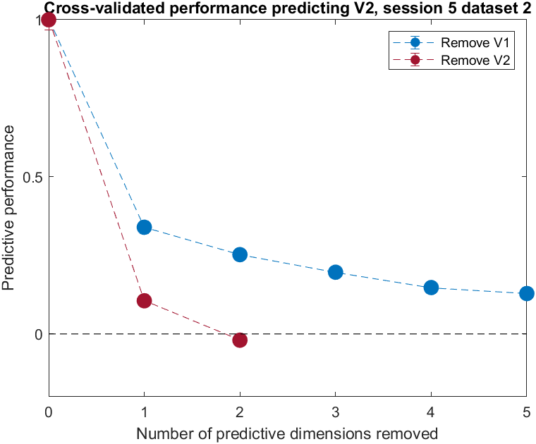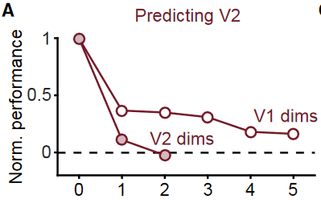

**Figure 6A**, **replication (left) vs original paper (right)** shows the effect on V2 prediction performance of removing source activity along dimensions predictive for target V1 and V2. Performance is normalized by that of the full ridge model (equivalent to the RRR model with no removed dimensions and no low-rank constraints1). As in the original paper, error bars are smaller than the plotted circles. For computational efficiency, an OLS model (instead of L2-regularized regression) was used as the initial model in RRR during the dimension removal routine, and our RRR loss function is then , where the latter term is a minimization problem with an analytic solution guaranteed via SVD (Eckart-Young theorem). Note as well that 10 repetitions, instead of the 25 in other parts of the study/replication, were used here, also to reduce the computational load. These (using OLS and 10 repetitions) are two potential sources of variability between the original data and replication in this dimension removal section.

[1]

It is interesting to note the dip below zero in both the original data and the replication at the point corresponding to removal of the two V2 predictive dimension. This seems to suggest that a model trained on source activity data with both predictive dimensions removed yields worse results than using the mean of that data for prediction (since, in order for R^2 to be negative, the sum of squared residuals must be larger than the total sum of squares (which measures deviations from the mean), such that R^2 = 1 – (RSS/TSS) is negative, as RSS> TSS. Then NSE = 1 – R^2 becomes larger than 1, and the loss, which is 1 – NSE becomes negative (generally, negative R^2 models seem to be associated with regression without intercepts, though it’s worth noting that we are operating on residuals here, and since the data are thus mean-centered at 0, the intercept should be zero)). For the original data, 0 may be within 1 SEM, but note that the majority of predictive performances for both replication and original data lie in the bin below zero in Figure 6B below (also see supplementary). This seems to suggest that projecting source activity onto source dimensions may actually be quite effective at destroying information in some way that makes it worse than a random model.

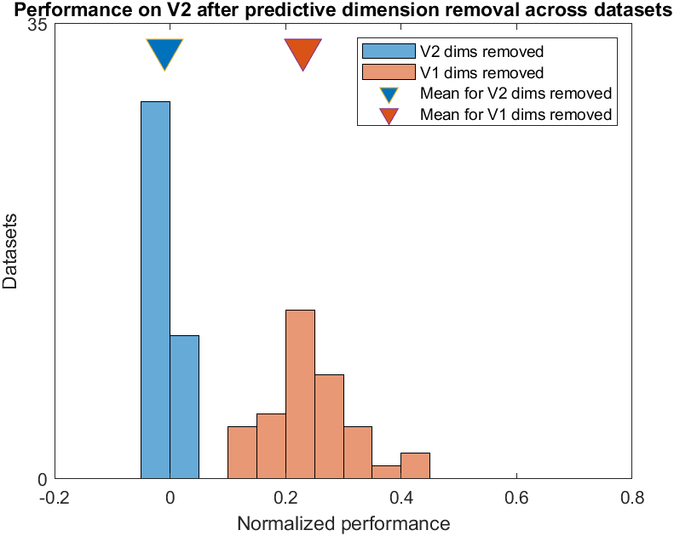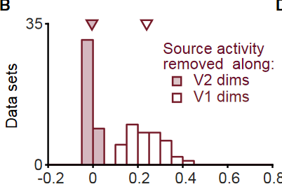

**Figure 6B**, **replication (left) vs** **original data (right)**: across datasets, removing V2 predictive dims destroys ability to predict V2 activity from source V1 activity; however, removal of the same number of V1 predictive dims fails to destroy prediction performance. Difference in performance between removing V1 and V2 was assessed with a right-tailed paired-permutation test, p = 9.999e-5. Each dataset’s performance is normalized by that of its full ridge model. These data suggest that the predictive dimensions for target V1 and V2 do not seem to significantly overlap.

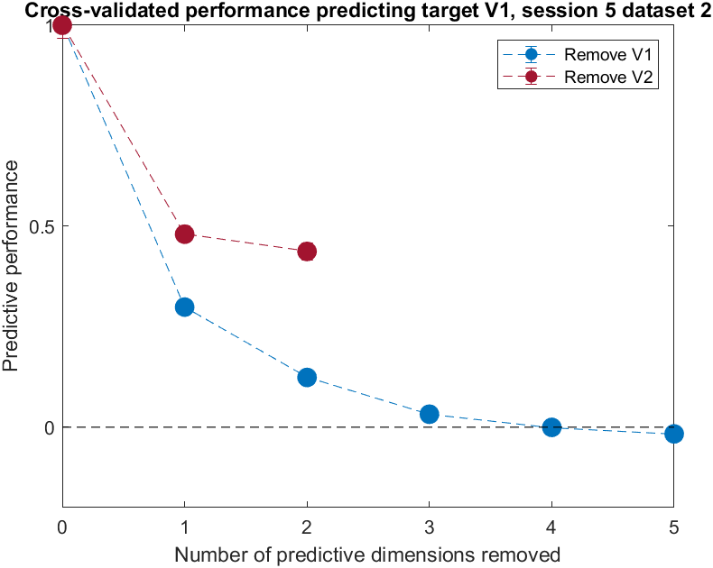 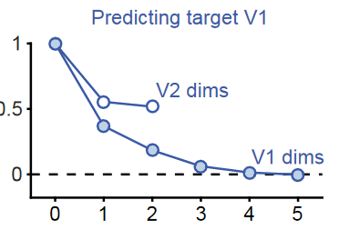

**Figure 6C**, **replication (left) vs original paper (right)** shows the effect on target V1 prediction performance of removing source activity along prediction dimensions for target V1 and V2, for an exemplar dataset. As in the original paper, error bars are smaller than the plotted circles.

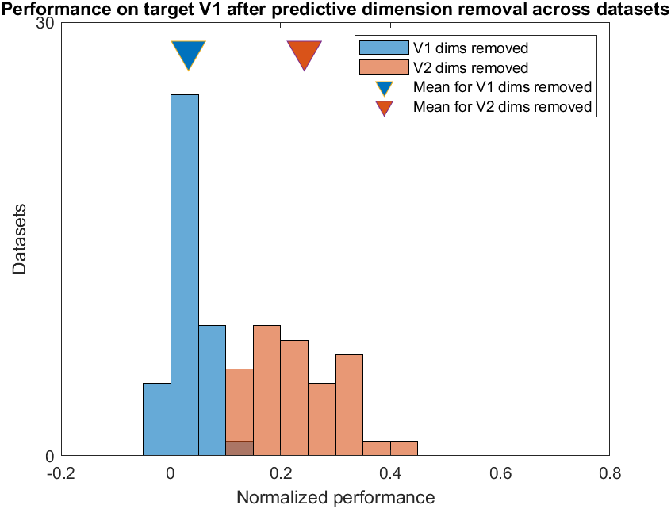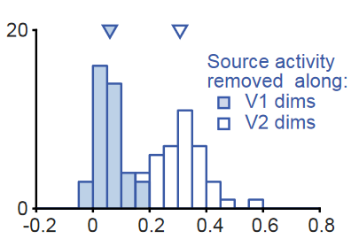

**Figure 6D**, **replication (left) vs original paper (right)** shows the effect on target V1 prediction performance of removing source activity along prediction dimensions for target V1 and V2, across all datasets (normalized by their respective full ridge models). Here, we drop all V2 predictive dimensions and the same number of V1 dimensions. Since nPredDimsV1 > nPredDimsV2, this means that not all V1 predictive dimensions are dropped, and we can see that some predictive ability remains. However, predictive performance for V1 is much more damaged than for V2 (right-tailed paired-permutation test, p = 9.999e-5), suggesting as in Figure 6B that predictive dimensions for target V1 and V2 are not well-aligned.

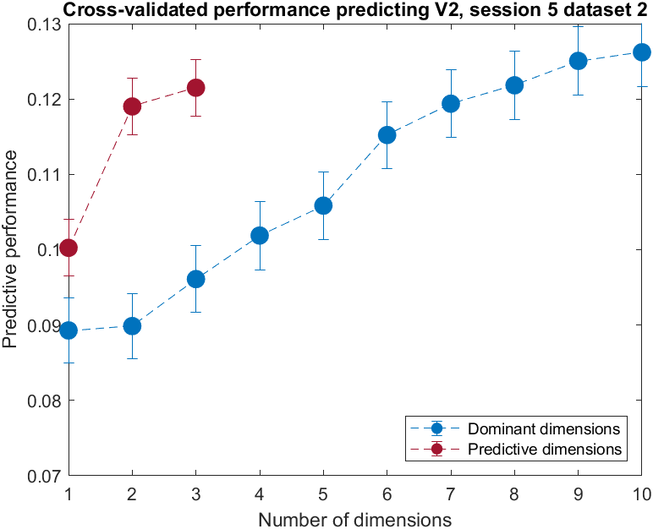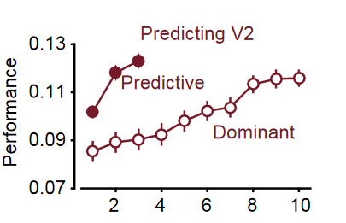

Figure 7A **replication (left) vs published (right)** When comparing two datasets corresponding to truly distinct brain regions (instead of partitioning one region’s dataset into two), we see a greater divergence between the explanatory power (with respect to explaining V2 variance) of V1 factors and V1 predictive dimensions, suggesting that there is a significant portion of V1 activity (captured by the factors) not communicated to V2 (along the predictive dimensions) and thus private to V1 (with respect to V2).

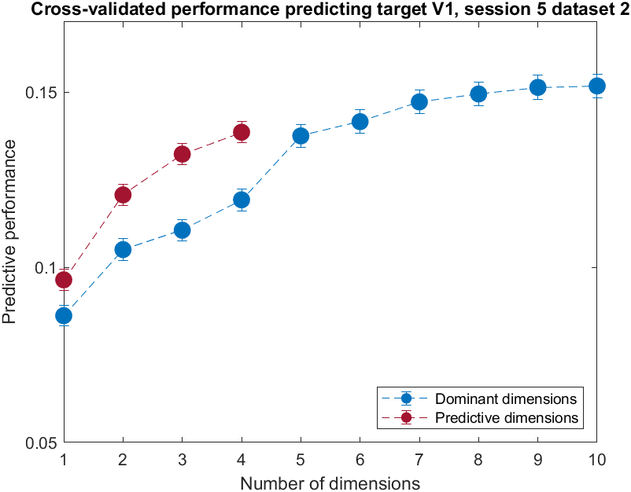 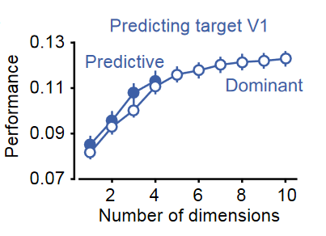

Figure 7B **replication (left) vs published (right)** When comparing two datasets corresponding essentially to partitions of the same dataset, we see a greater overlap between dominant factors and predictive dimensions. This makes sense, as it suggests that V1 is not “private” from itself.

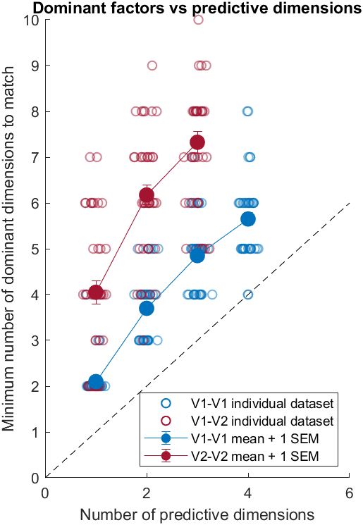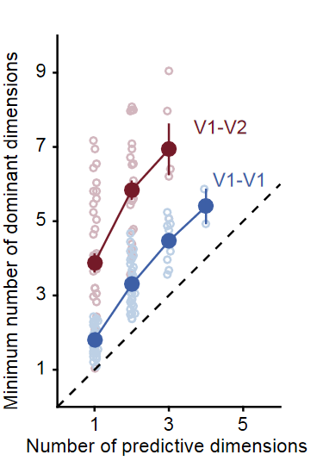

**Figure 7C** **replication (left) vs published (right)** As with the published data, it takes generally takes more factors to achieve prediction performance comparable to that achieved by a fewer number of predictive dimensions from RRR. This makes sense, as RRR essentially selects “factors” based on the criteria that they explain as much target variance as possible, regardless of how much or little source variance they explain (and in fact they may not explain much source variance at all)—that is, RRR takes into account mainly target variance, as well as correlation between target and source activity. Factor regression (FR) on the other hand uses factors that were selected to explain as much shared source variance as possible, and these dimensions need not capture much target variance at all—that is, FR essentially optimizes only for source variance. (Partial least squares tries to balance these objectives (source variance, target variance, source-target correlation), while CCA searches for latents that are maximally correlated between the datasets, but without much other emphasis on variance explained etc.)

We can also observe that the effect is more pronounced when comparing V1-V2 vs V1-V1. When operating within the same region, there will naturally be more overlap between dominant factors and strong predictive dimensions (after all, we are really just partitioning one dataset into two). However, when we consider datasets corresponding to truly distinct brain regions, we see a greater divergence between the factor dimensions capturing shared source variance and the predictive dimensions capturing target (V2) variance, allowing for the formation of so-called “private-dimensions” and “communicating-dimensions” forming a “communication subspace.”

**Supplementary**

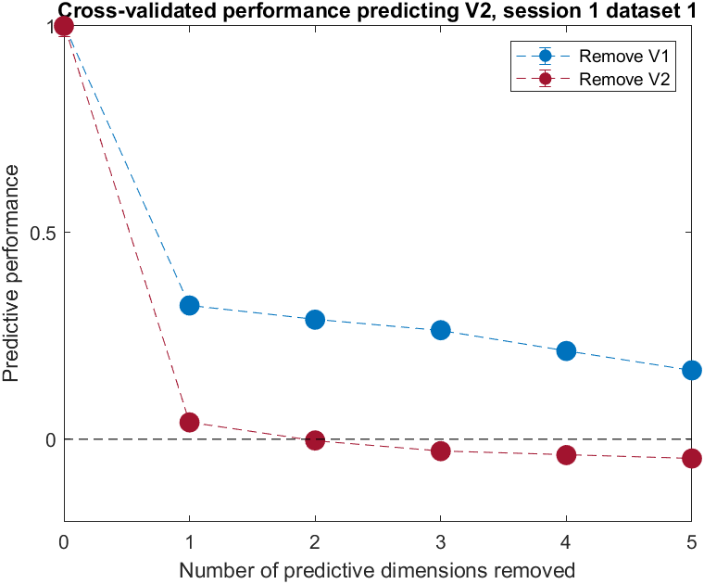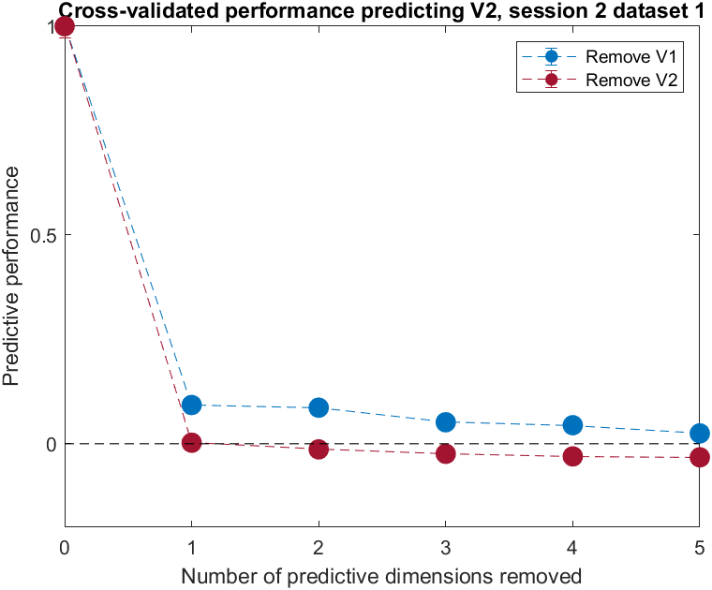

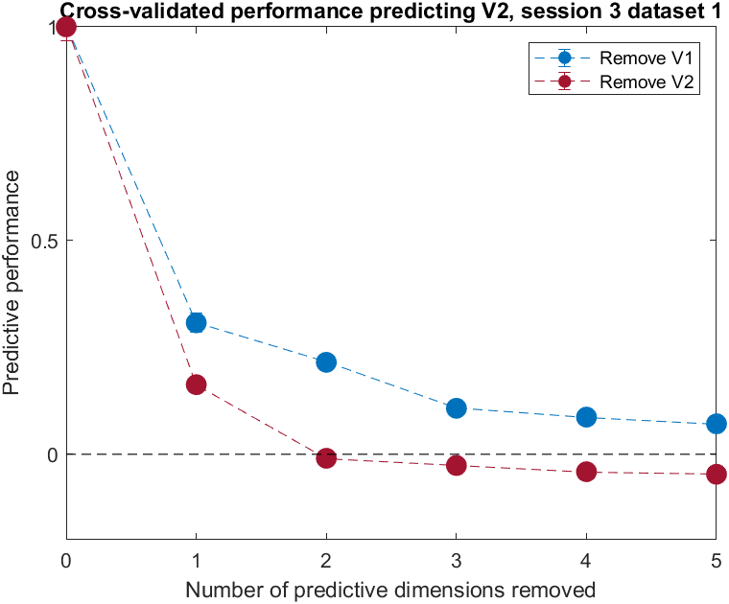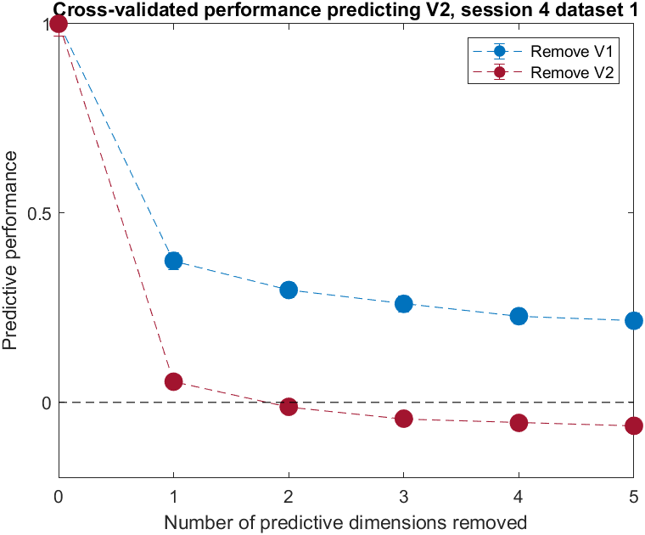

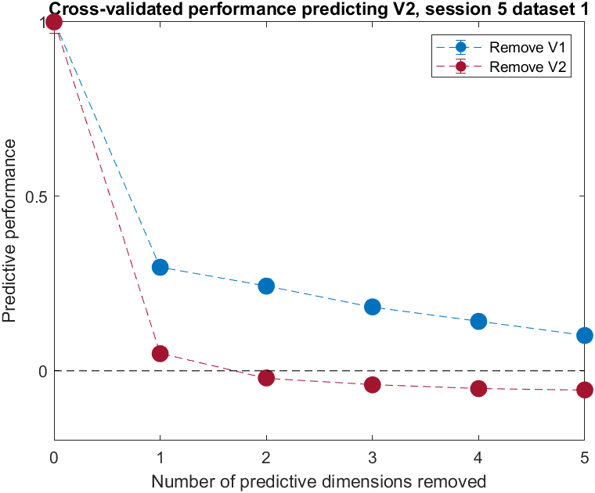

Datasets corresponding to stimulus type 1, across sessions. If we continue to drop predictive dimensions for V2, performance dips steadily below 0 (becomes increasingly worse than using the mean for prediction).

1. The paper states that performance is normalized performance by that of the RRR model with no source activity removed. There is no rank constraint mentioned (and it does not seem to make much sense to reduce the rank of by the same number as that by which the rank of was reduced: removing source activity along one predictive dimension may, e.g., reduce the source activity rank() = 133 to rank() = 132, and this does not seem directly equivalent in any clear way to reducing the rank of the target population reconstruction from, e.g., 25 to 24). If we interpret the statement then as indicating that all columns of (equal in number to nNeuronsTarget because the target regions always had less units) are to be retained, we note that will be a two-sided (i.e., right-sided as well as left-sided) inverse of . Then the projection matrix , and , meaning that the RRR model is equivalent to the full ridge model.